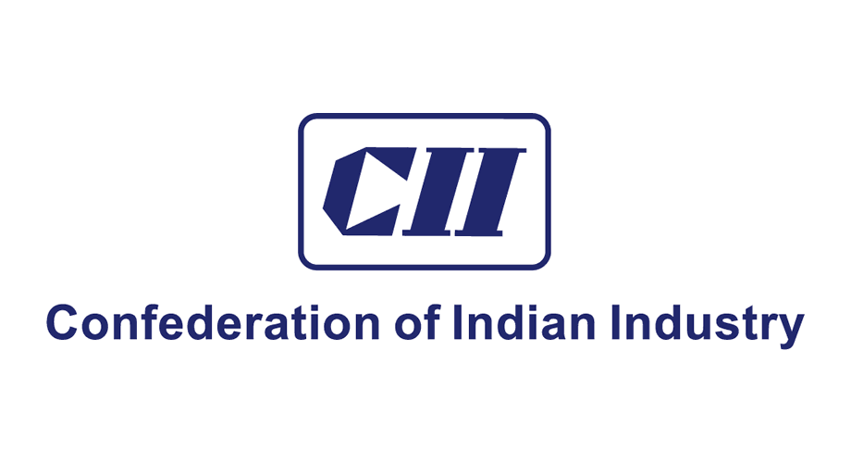

**CII National Award for Excellence in Energy Management 2023**

**GUIDELINES & SUGGESTIONS FOR FILLING**

**INNOVATION PART OF QUESTIONNAIRE**

**Innovation**

Innovation in its modern meaning is "a new idea, creative thoughts, new imaginations in form of device or method". Innovation is often also viewed as the application of better solutions that meet new requirements, unarticulated needs, or existing market needs.

**Understanding Innovation in Energy Efficiency**

Innovation in Energy Efficiency is the set of processes leading to new or improved energy technologies that can augment energy resources; enhance the quality of energy services; and reduce the economic, environmental, or political costs associated with energy supply and use.

***Innovation also is dynamic in nature, as what was innovative in the past may be not so innovative now and what is innovative now may not be innovative in the future.***

The ideas presented by the organisation must be new, innovative and something which are very uncommon and have a high replication potential. The below are the 4 categories under which the innovation has been broadly described:

1. **Category A First Time Implementation on global level:**

These are the energy conservations methods which could have been implemented by the plant for the first time at International level.

Some of the examples for the above category are:

* 1. Utilization of Artificial Intelligence (AI) for improving energy efficiency
  2. Use of Energy Storage
  3. Use of Solar Thermal to augment steam in thermal power plants.
  4. Heat Recovery from Kiln Shell Radiation in Cement Sector

**While mentioning the projects in this category the plants should also mention if they have acquired any IPR (Intellectual Property rights) protections for the same.**

1. **Category B First Time Implementation on national level:**

These are the energy conservations methods which could have been implemented by the plant for the first time at a national level.

Some of the Examples for the above category are:

* 1. Installation of Organic Rankine Cycle to utilize low waste grade waste heat: One of the leading cement sector companies in India installed first 4.8 MW organic Rankine cycle-based power plant in India at its site in the year 2006. The installation when done was one of the first installations in the country.
  2. Installation of flue gas-based vapour absorption machine: One of the leading Power Sector Companies in the country installed first flue gas-based vapour absorption machine for utilizing in air conditioning in plant. When done this was one of the first installations of such kind in the world.
  3. Installation of Bifacial solar panels for power generation

These were some of the unique project which when done by some of the companies were projects done for the first time in India.

**While mentioning the projects in this category the plants should also mention if they have acquired any IPR (Intellectual Property rights) protections for the same.**

1. **Category C New Concept (risk taken/self-driven / beyond OEM):**  This category is for a new concept which have been implemented by the organisation which is totally new and has been implemented by the plant by taking some risks (either technical, financial). The concept may be self-driven and even beyond OEM permissions or interventions.

For Example:

* 1. These may include major modifications to existing system where the plants have gone beyond the OEMs by taking significant technical and financial risks like major modifications in furnaces and boilers helping improve the overall efficiency and production levels.
  2. One of the leading power sector companies was one of the first to have installed VFDs in Condensate Extraction Pump (HT Drives) in the country. Seeing the criticality of the equipment and its major involvement in the overall reliability of the plant, it was considered a major innovation at that time. Many other power sector companies later followed path and now this has become a common project in many thermal power plants.
  3. One of the leading petrochemical sector company was one of the first to have installed inlet air cooling for their gas compressors. The project when implemented was one of the first in the sector as well as in the country. The project was also critical in its nature and was in several ways an initiative beyond OEM interventions.

1. **Category D Known concept unique application:** This category consists of energy conservation methods with a known concept but unique application.

For Example: Variable frequency drives (VFDs) are a very common concept and have been used by plants in various applications like pumps, fans etc. So, we can say that it is a known concept. Beside these areas some of the new areas where VFDs are finding their place in the recent time are:

* 1. VFDs in Conveyors with changing loads
  2. Use of VFDs to run induction motors at higher frequencies
  3. Use of VFDs in CNC machines

**What kind of Projects are not Innovative Projects?**

The projects which are very common in nature and have been implemented by several companies will not fall in the category of innovative projects. Following are some of the examples of ‘not innovative projects’

1. LED Lighting Projects
2. VFDs in fans, pumps, compressors.
3. Solar Rooftop Projects

And other similar projects.

**Notes:**

1. The marks in the brackets are suggested marks for the project in the particular category. These are indicative marks the final marks will be based on judge’s discretion.
2. Many projects may lie in multiple categories, Hence the plants while mentioning the category must mention the one with highest relevance.
3. Many of the projects mentioned in the guidelines would have been innovative when they were implemented but may not be innovative now!
4. Mention the use of IPR protections taken for any projects if applied or obtained.